**Google Sign In Setup Guide**

1. Google Developer Console settings
2. Django Super Admin settings

**Google Developer Console settings**

1. Click on the following link to access Google developer Console: <https://console.developers.google.com/>

For first timer users, do check the “I agree to the Google Cloud Platform… terms of service” and click on “Accept”.

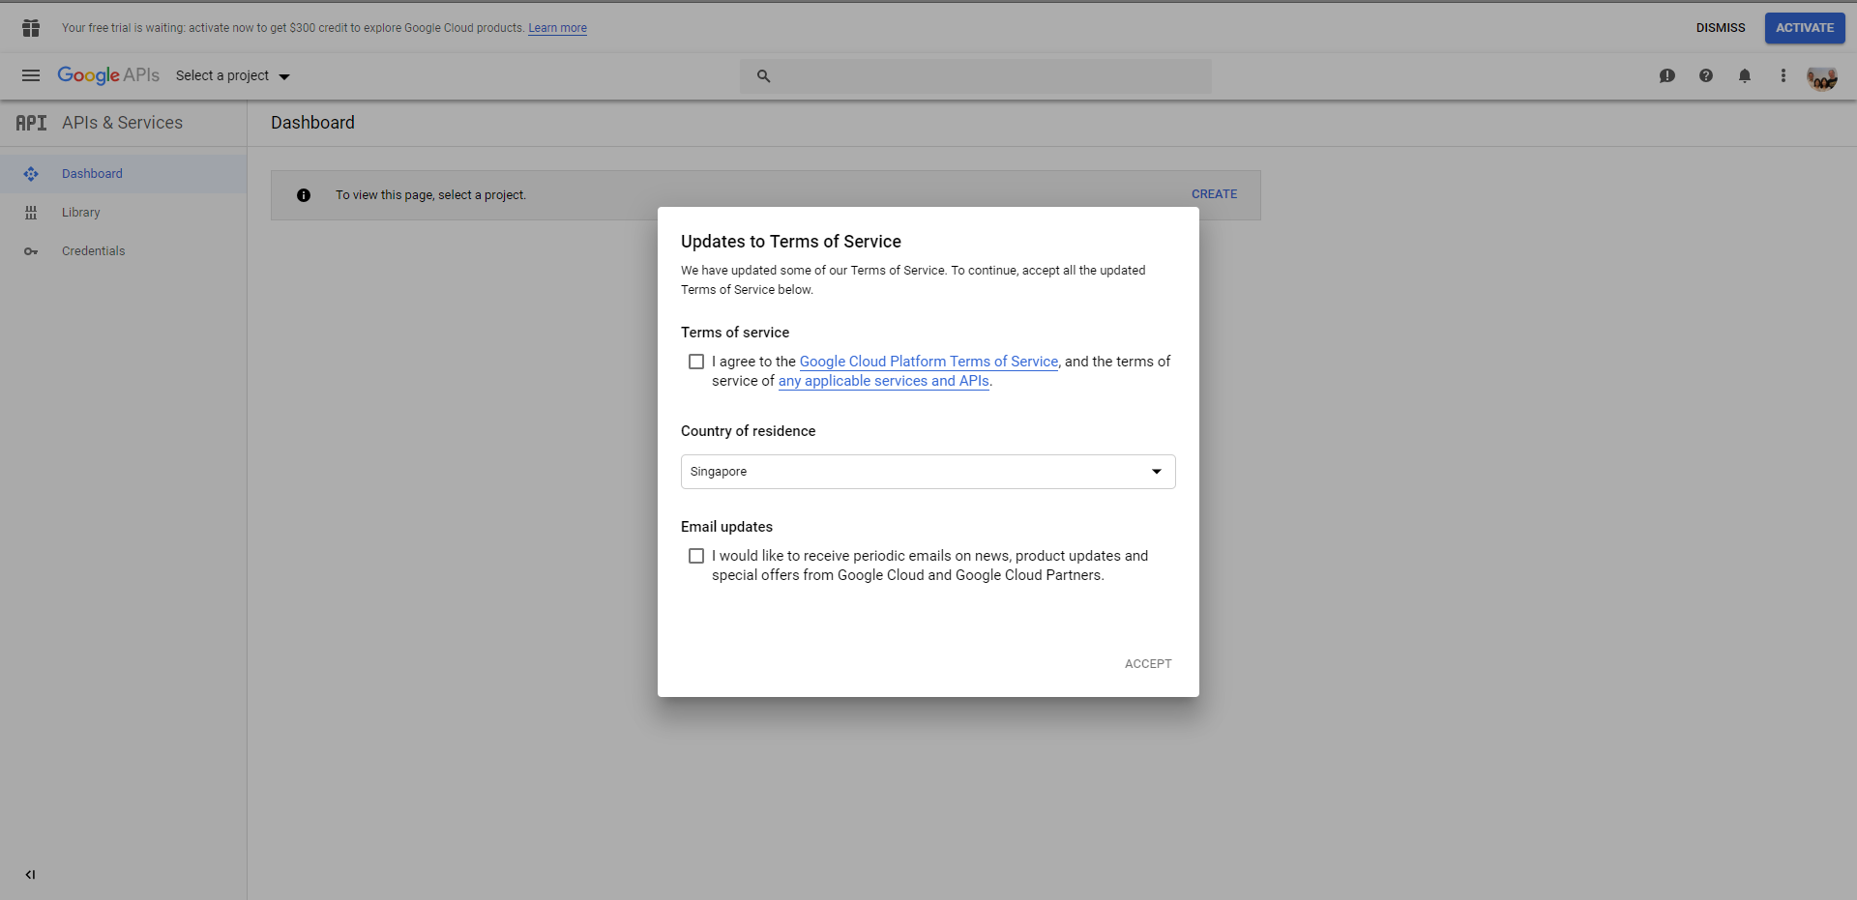

1. To create a new project, click on “Select a project” then “NEW PROJECT”.

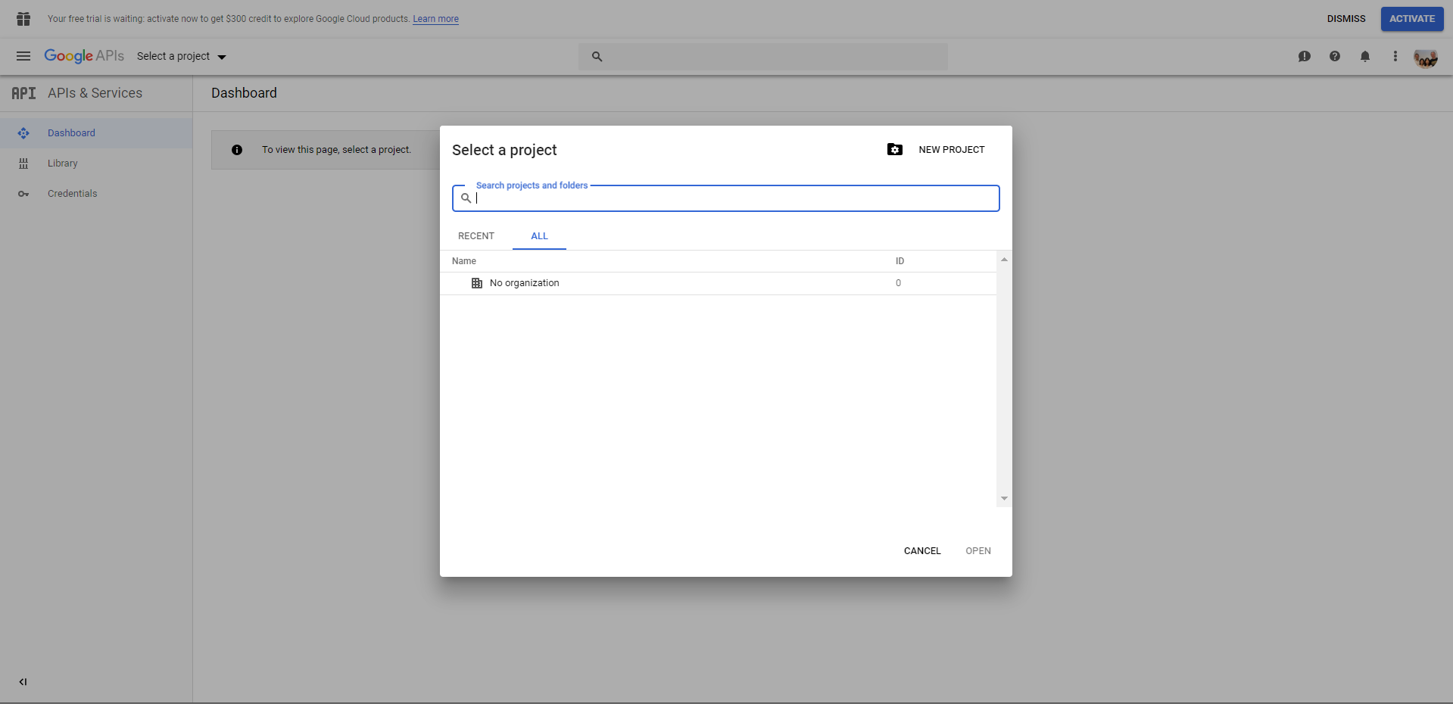

1. Key in your preferred Project Name and click on “CREATE”.

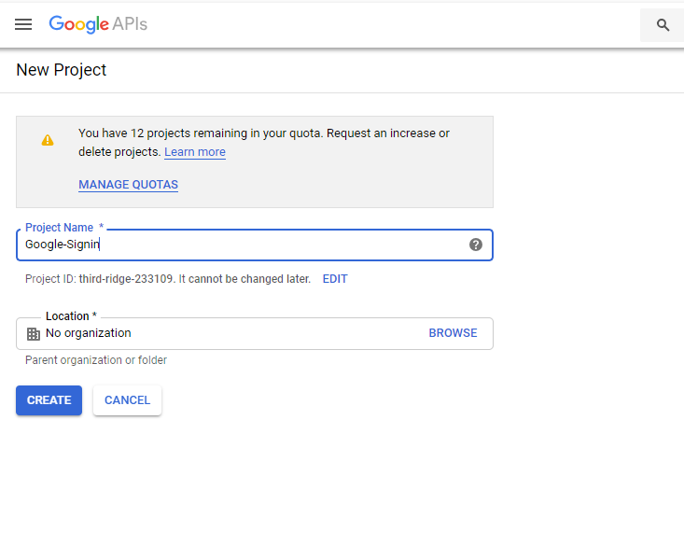

1. Select “Credentials” on the side bar and click on “Create credentials”.

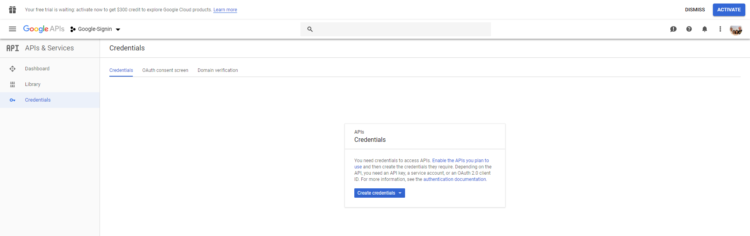

1. Select “OAuth client ID” for Google Sign In authentication services.

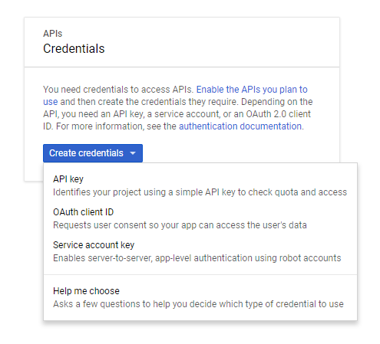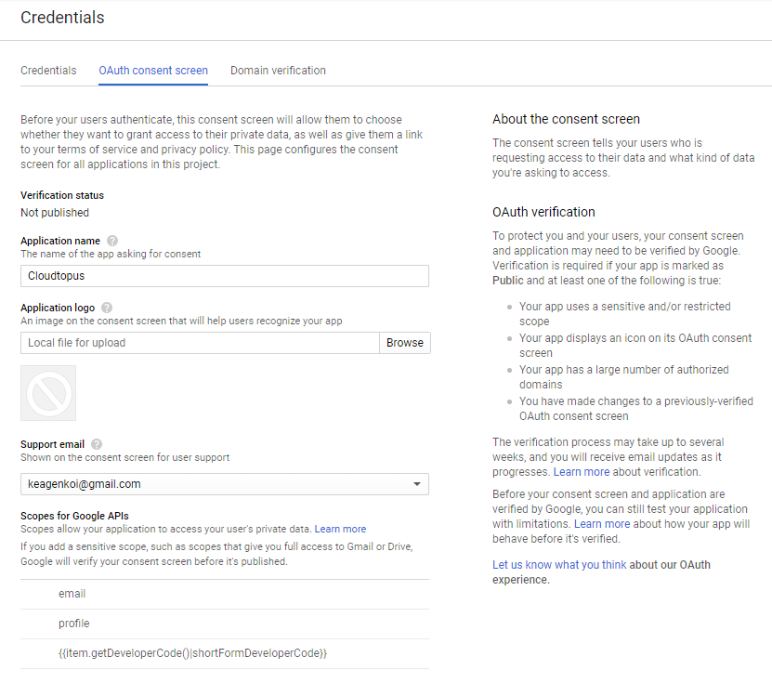

1. If it is your first time setting up, click on “Configure consent screen”.

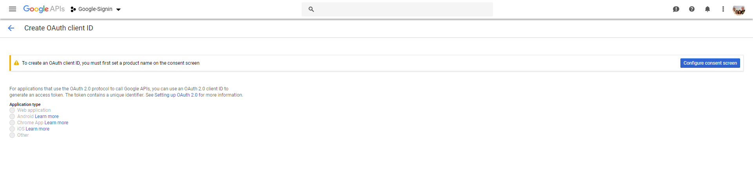

1. In here, the only setting you have to edit is the “Application name” and “Authorized domains”

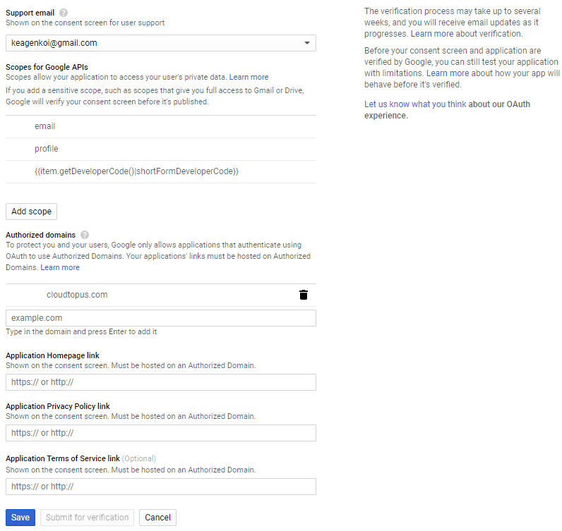

1. Select “Web application” for the “Application type” and fill in the respective fields as shown in the figure below. Do note that “Authorized redirect URIs” should be in this format: “https://www.XXXXXXXXX.com/**accounts/google/login/callback/**”. After completing the fields, click on “Create”.

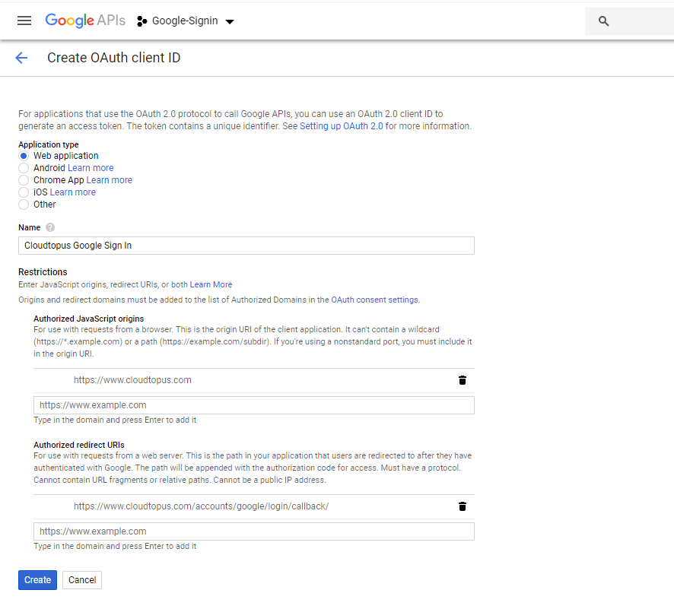

1. After which, OAuth client will provide you with the client ID and client secret. The information is always readily accessible on the console later, so just click on “OK”.

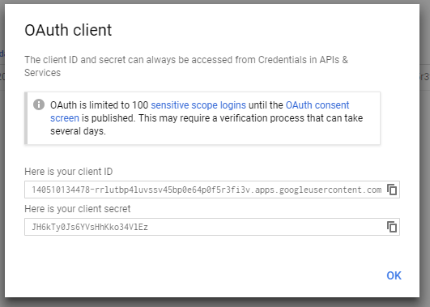

**<< End of Google Developer Console settings >>**

**Google Developer Console settings**

1. Click on the following link to access Cloudtopus super admin page: <https://cloudtopus.com/admin/> (Please refer to “cloudtopus system admin file.xlsm” for the login credentials).

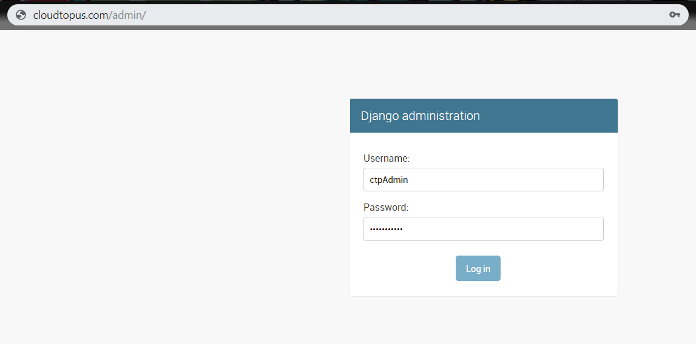

1. Go under “SITES” and select “Add”

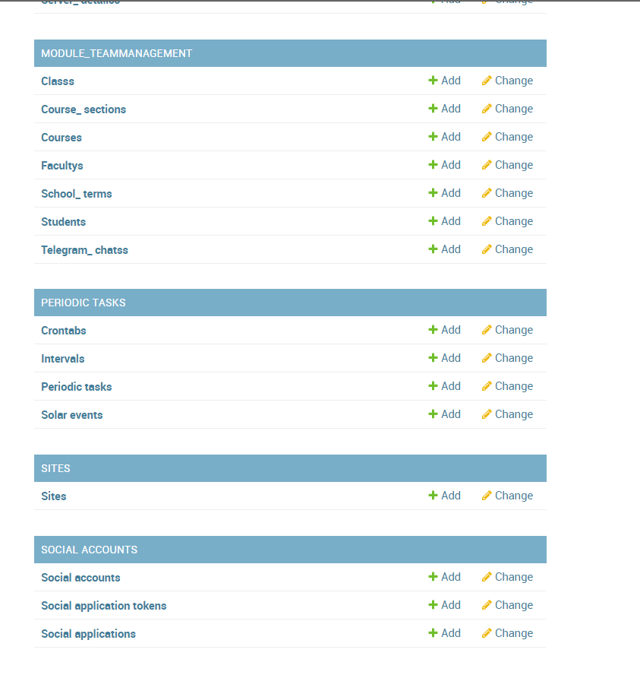

1. Under “Domain name” key in the domain of your website, key in your desired display name in the “Display name” field. Afterwards, click “SAVE”.

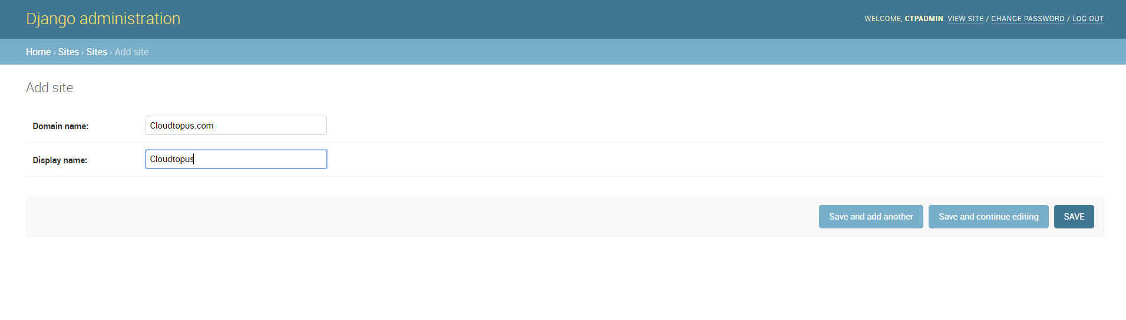

1. Select “Google” for “Provider”. Under “Name”, key in your desired name. For “Client id” and “Secret key”, input the credentials as created in the Google Developer Console. Double click on your site that you have created in the previous step to move it from “Available sites” to “Chosen sites”. After which select “SAVE”.

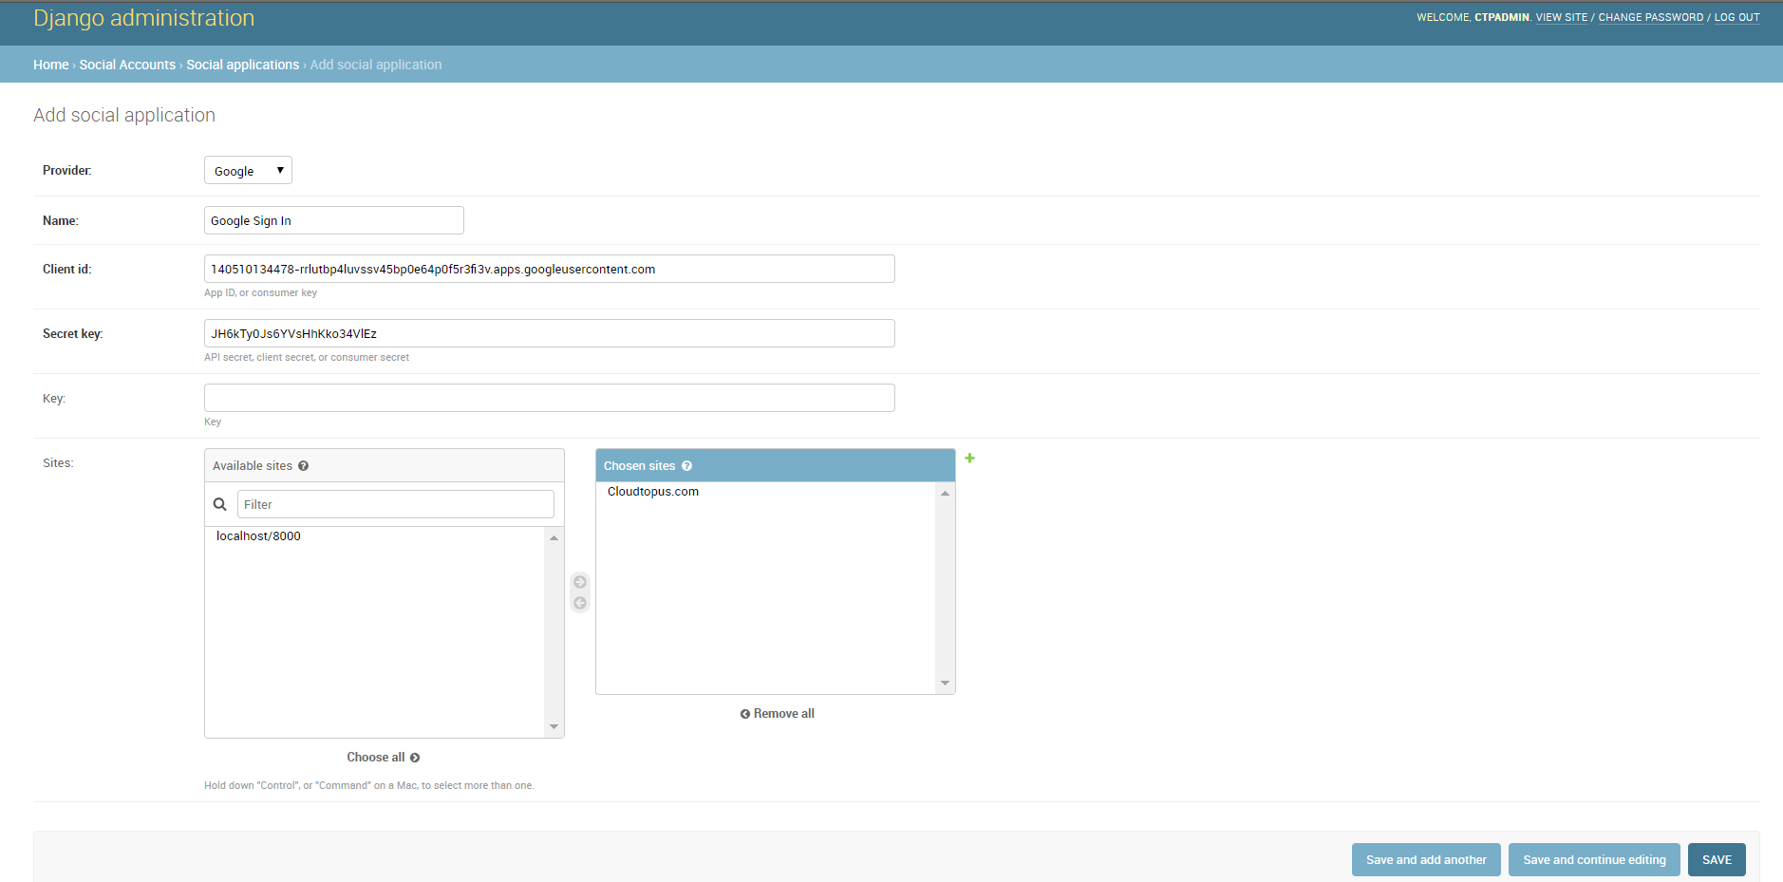

**<< End of guide >>**